-- Write a query to display the total information of the teachers who are in the EEE department.

select * from Tbl_Teacher inner join Tbl_Dept

on Tbl_Teacher.DeptID = Tbl_Dept.DeptID where Tbl_Dept.DeptName ='EEE';

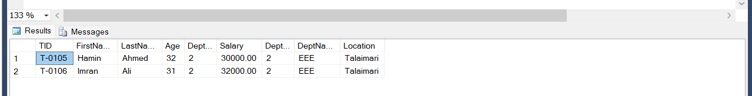

--Write a query to find the total number of teachers for each department in descending order.

select DeptName as Departmentname, count(TID) as Total_Teacher from Tbl_Teacher inner join Tbl_Dept

on Tbl_Teacher.DeptID = Tbl_Dept.DeptID group by DeptName order by Total_Teacher desc;

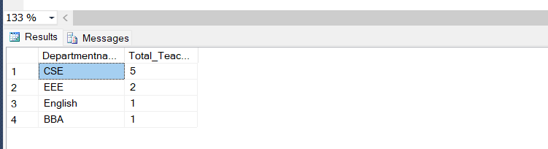

-- Write a query to find the name of the teacher who teaches more than one course.

select FirstName, LastName from Tbl_Teacher join Tbl_Course on Tbl_Teacher.TID = Tbl_Course.TID

group by Tbl_Teacher.TID, Tbl_Teacher.FirstName, Tbl_Teacher.LastName having count(Tbl_Course.Course_Code)>1;

-- Write a query to find the minimum salary of a Teacher for each department where the salary is

--less than the average salary.

SELECT D.DeptName AS Department, MIN(T.Salary) AS MinimumSalary FROM Tbl_Teacher T JOIN Tbl_Dept D ON T.DeptID = D.DeptID

GROUP BY D.DeptName

HAVING MIN(T.Salary) < (

SELECT AVG(Salary)

FROM Tbl_Teacher

);

--Write a query to find the top 2 departments with the highest total salaries of teachers. Display

--the department name and total salary in descending order.

SELECT TOP 2 D.DeptName AS DepartmentName, SUM(T.Salary) AS TotalSalary

FROM Tbl_Teacher T

JOIN Tbl_Dept D ON T.DeptID = D.DeptID

GROUP BY D.DeptName

ORDER BY TotalSalary DESC;

-- Write a query to find the teachers who do not teach any course.

SELECT T.FirstName, T.LastName

FROM Tbl_Teacher T

LEFT JOIN Tbl_Course C ON T.TID = C.TID

WHERE C.Course_Code IS NULL;

--Update the Salary of the Teacher by 15% whose DeptName is ‘CSE’, otherwise update by 10%

--Salary.

UPDATE Tbl_Teacher

SET Salary = CASE

WHEN DeptID = (SELECT DeptID FROM Tbl_Dept WHERE DeptName = 'CSE') THEN Salary * 1.15

ELSE Salary * 1.10

END

WHERE DeptID = (SELECT DeptID FROM Tbl_Dept WHERE DeptName = 'CSE');

select* from Tbl_Teacher;

-- Write a query to find the first name, and salary for all the teachers of CSE who have a higher

--salary than Faruk Alam.

select FirstName, Salary from Tbl_Teacher inner join Tbl_Dept on Tbl_Teacher.DeptID = Tbl_Dept.DeptID

where Tbl_Dept.DeptName='CSE' and Tbl_Teacher.Salary>(select Salary from Tbl_Teacher where TID ='T-0103');

